# DAY 1: POWER BI BASIC MEASURES EXERCISES

# Exercise 1: There are three tables in the films dataset. The tables are; Certificate, films, and genre. Create a Film Measure to hold your measures. You need to create the following measures:

Average Box Office: to show average box office takings (dividing by 1,000,000 to make figures more readable)

Average Profit: to show average difference between the box office takings and budget for each film.

Number of films: to count the no. of films for the filter context (use COUNTROWS)

# Average Box Office:

Using AVERAGEA function to calculate the average box office films and dividing it by 1,000,000 for better readability.



# Average Profit:

Using AVERAGEX function to extract the Films table and apply an expression which helps to calculate the difference between box office and Budget.



# Number of Films

Using COUNTROWS function to calculate the count of each film across each row.

# Final Result:

The final result obtains the following table visualization:

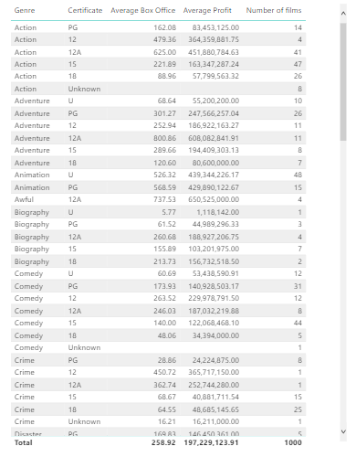

Exercise 2: A dataset about tallest buildings is given. You need to create following measures:

* Total height: Create a new measure in the building measures table. Use the SUM function to calculate the height m column.
* Average height: Add a new measure to the building measures table. Use AVERAGE function to calculate the average of the height (sort in descending order.)
* Tallest height: Use MAX function to calculate the buildings with tallest height.
* Shortest height: Use MIN function to calculate the buildings with short height
* Height range: Calculate the difference between shortest height and tallest height to obtain the range.
* Average floor height: takes the SUM of Height m column and divides it by the SUM of floors above ground column.
* Total floors: Use SUMX function to return the total number of floors above ground column plus floors below ground column.
* Average floors: This should return the average of Floors above ground plus Floors below ground.

NOTE: I’m directly writing the answers here as the pbix file was not compatible to my current version of Power BI.

# Total Height:

Total Height = SUM([Height m])

# Average Height:

Average Height = AVERAGE([Height m])

# Tallest Height:

Tallest Height = MAX([Height m])

# Shortest Height:

Shortest Height = MIN(Height m])

# Height Range:

Range = Tallest Height – Shortest Height

# Average Floor Height:

Average_floor_height = SUM(Height m]) / SUM([Floors above ground])

# Total Floors:

Total Floors = SUMX(floors, floors[Floors above ground] + floors[Floors below ground])

# Average Floors:

Average Floors = AVERAGEX(floors, floors[Floors above ground] + floors[Floors below ground]).